**Name: Thorve Avishkar Shrikrushna**

**Roll No.: 62**

**Practical No.01**

**Query:**

-- 1. Create Employees Table with constraints

CREATE TABLE Employees (

EmpID INT PRIMARY KEY,

FirstName VARCHAR(50),

LastName VARCHAR(50),

Department VARCHAR(50),

Salary DECIMAL(10, 2),

JoiningDate DATE,

Email VARCHAR(100) UNIQUE,

CONSTRAINT chk_Salary CHECK (Salary > 0)

);

-- 2. Create an Index on Department

CREATE INDEX idx_Department ON Employees (Department);

-- 3. Insert sample data

INSERT INTO Employees (EmpID, FirstName, LastName, Department, Salary, JoiningDate, Email)

VALUES (1, 'John', 'Doe', 'IT', 60000, '2023-05-15', 'john.doe@example.com');

INSERT INTO Employees (EmpID, FirstName, LastName, Department, Salary, JoiningDate, Email)

VALUES (2, 'Jane', 'Smith', 'HR', 45000, '2022-10-12', 'jane.smith@example.com');

-- 4. Select all data from Employees

SELECT * FROM Employees;

-- 5. Update Salary for a specific Employee

UPDATE Employees

SET Salary = 70000

WHERE EmpID = 1;

-- 6. Delete an Employee

DELETE FROM Employees

WHERE EmpID = 2;

-- 7. Select Employees with Salary > 50000

SELECT FirstName, LastName, Salary

FROM Employees

WHERE Salary > 50000;

**Output :**

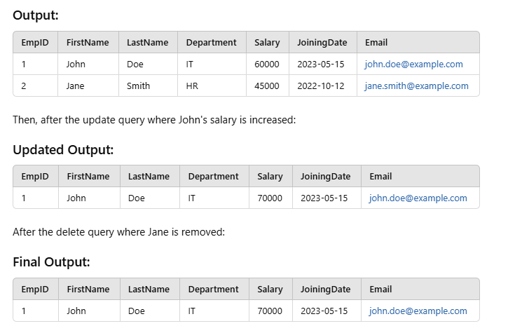

**Name: Thorve Avishkar Shrikrushna**

**Roll No.: 62**

**Practical No.02**

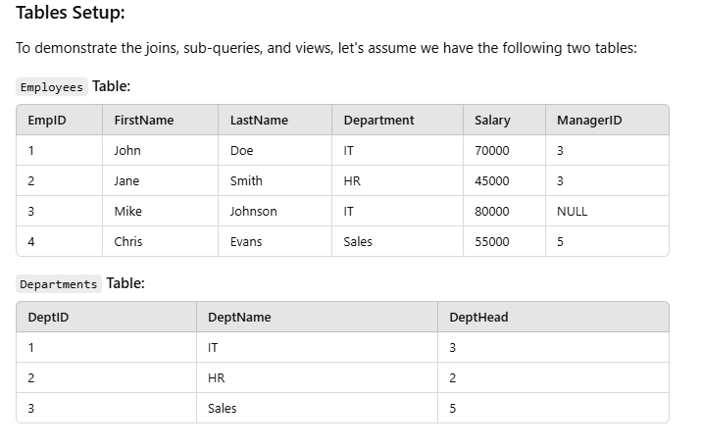

1. **INNER JOIN: Join Employees with Departments (matching records only)**

SELECT e.FirstName, e.LastName, d.DeptName

FROM Employees e

INNER JOIN Departments d

ON e.Department = d.DeptName;

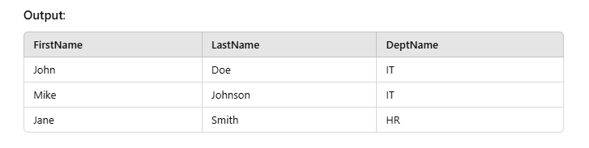

**-- LEFT JOIN:** Select all Employees with Departments, showing NULL where no department exists

SELECT e.FirstName, e.LastName, d.DeptName

FROM Employees e

LEFT JOIN Departments d

ON e.Department = d.DeptName;

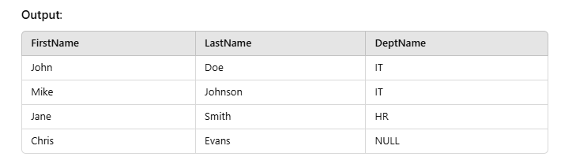

**-- RIGHT JOIN:** Select all Departments with Employees, showing NULL where no employee exists

SELECT e.FirstName, e.LastName, d.DeptName

FROM Employees e

RIGHT JOIN Departments d

ON e.Department = d.DeptName;

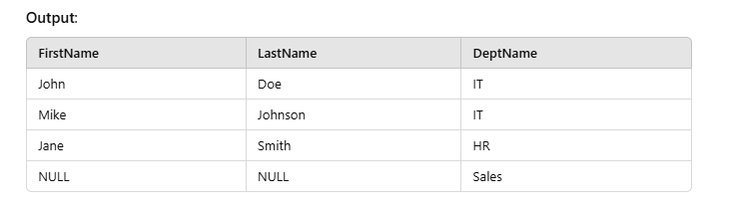

**-- FULL OUTER JOIN:** Select all Employees and all Departments, showing NULL where no match exists

SELECT e.FirstName, e.LastName, d.DeptName

FROM Employees e

FULL OUTER JOIN Departments d

ON e.Department = d.DeptName;

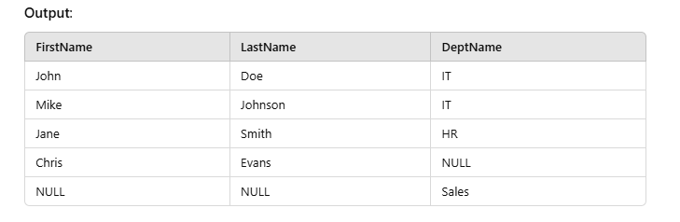

**-- SELF JOIN:** Find Employees and their Managers

SELECT e.FirstName AS Employee, m.FirstName AS Manager

FROM Employees e

LEFT JOIN Employees m

ON e.ManagerID = m.EmpID;

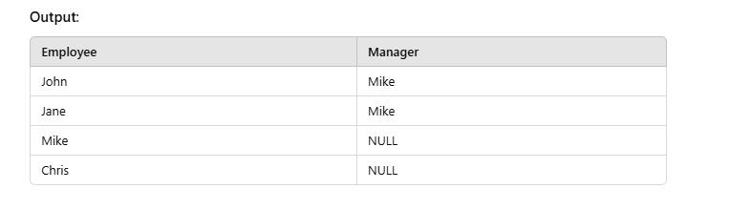

**-- Sub-Query**: Select Employees whose salary is greater than the average salary of all Employees

SELECT FirstName, LastName, Salary

FROM Employees

WHERE Salary > (SELECT AVG(Salary) FROM Employees);

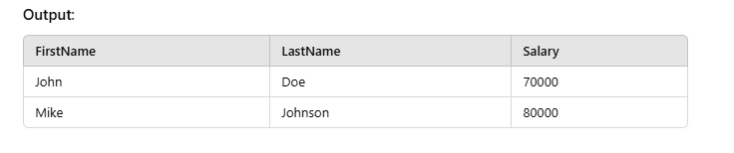

**-- Sub-Query**: Select Departments where Employees are currently working

SELECT DeptName

FROM Departments

WHERE DeptID IN (SELECT DISTINCT Department FROM Employees);

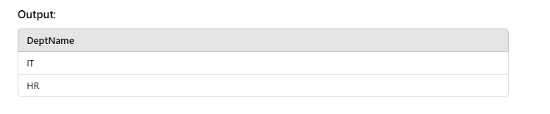-- **Correlated Sub-Query:** Select Employees whose salary is greater than the average salary of their department

SELECT e.FirstName, e.LastName, e.Salary

FROM Employees e

WHERE e.Salary > (SELECT AVG(Salary)

FROM Employees

WHERE Department = e.Department);

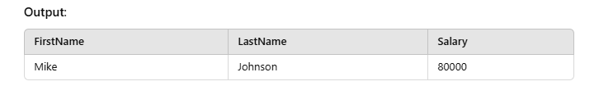

**-- View:** Create a view for Employees with Salary greater than 60000

CREATE VIEW HighSalaryEmployees AS

SELECT FirstName, LastName, Department, Salary

FROM Employees

WHERE Salary > 60000;

-- Query to select from the view

SELECT * FROM HighSalaryEmployees;

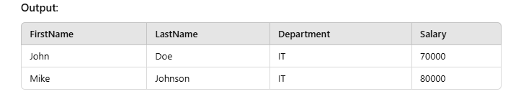

**-- CROSS JOIN:** Select all possible combinations of Employees and Departments

SELECT e.FirstName, e.LastName, d.DeptName

FROM Employees e ROSS JOIN Departments d;

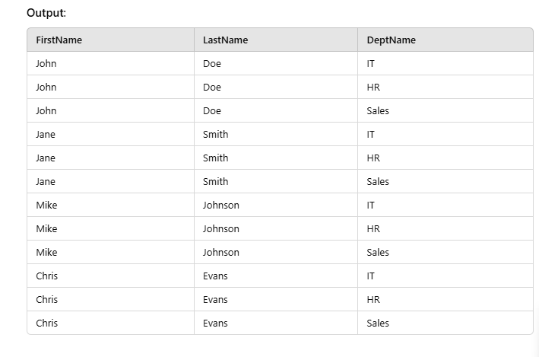

**Name: Thorve Avishkar Shrikrushna**

**Roll No.: 62**

**Practical No.03**

**Insert Documents (Create Operation):**

// Insert a single document

db.employees.insertOne({

EmpID: 1,

FirstName: "John",

LastName: "Doe",

Department: "IT",

Salary: 70000,

ManagerID: 3

});

// Insert multiple documents

db.employees.insertMany([

{

EmpID: 2,

FirstName: "Jane",

LastName: "Smith",

Department: "HR",

Salary: 45000,

ManagerID: 3

},

{

EmpID: 3,

FirstName: "Mike",

LastName: "Johnson",

Department: "IT",

Salary: 80000,

ManagerID: null

}

]);

**Query : Matching values using $and operator**

db.contributor.find({$and: [{branch: "CSE"}, {joiningYear: 2062}]}).pretty()

**Output :**

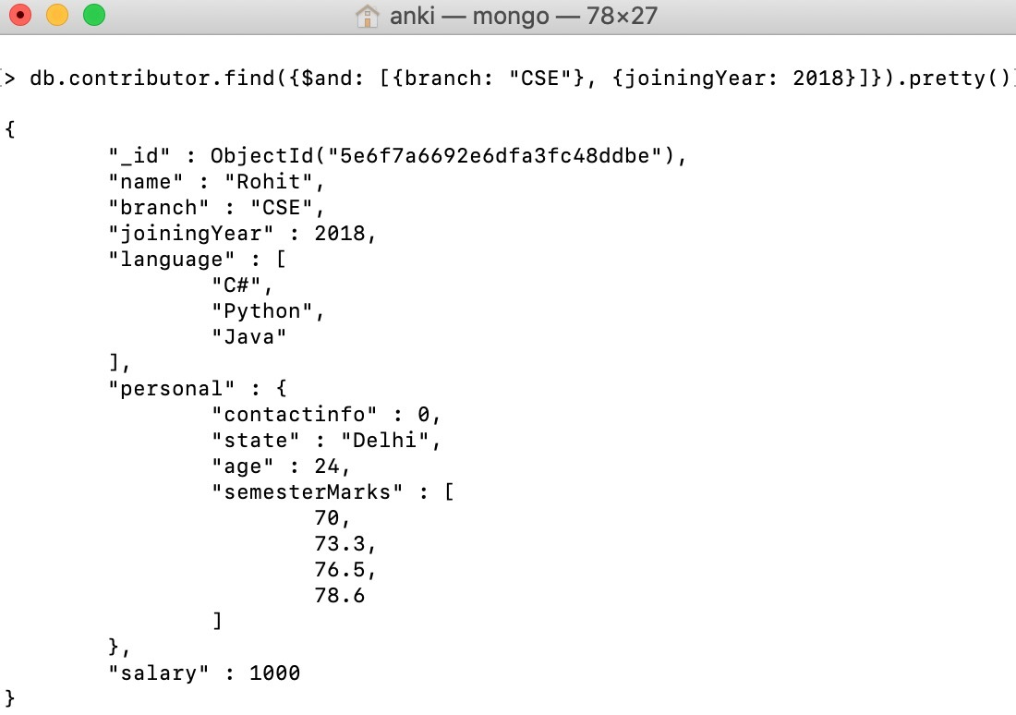

**Name: Thorve Avishkar Shrikrushna**

**Roll No.: 62**

**Practical No. 04**

**Schema:**

1. **Borrower(Rollin, Name, DateofIssue, NameofBook, Status)**
2. **Fine(Roll_no,Date,Amt)**

* ***Accept roll_no & name of book from user.***
* ***Check the number of days (from date of issue), if days are between 15 to 30 then fine amount will be Rs 5per day.***
* ***If no. of days>30, per day fine will be Rs 50 per day & for days less than 30, Rs. 5 per day.***
* ***After submitting the book, status will change from I to R.***
* ***If condition of fine is true, then details will be stored into fine table.***

SQL> create table Borrower(

2 rollin integer,

3 name varchar(20) not null,

4 dateofissue date not null,

5 nameofbook varchar(20) not null,

6 status varchar(2) default 'I');

Table created.

insert into Borrower values (1,'Shree',TO_DATE('08/09/2020','dd/mm/yyyy'),'CN','I');

insert into Borrower values (2,'Krishna',TO_DATE('20/09/2020','dd/mm/yyyy'),'DBMS','I');

insert into Borrower values (3,'Madhav',TO_DATE('25/10/2020','dd/mm/yyyy'),'ISEE','I');

insert into Borrower values (4,'Mukund',TO_DATE('03/10/2020','dd/mm/yyyy'),'SEPM','I');

insert into Borrower values (5,'Mohan',TO_DATE('27/10/2020','dd/mm/yyyy'),'TOC','I');

insert into Borrower values (1,'Shree',TO_DATE('25/09/2020','dd/mm/yyyy'),'TOC','I');

SQL> create table fine(

2 rollno integer,

3 fine_date date not null,

4 amt float not null);

Table created.

create or replace procedure finer(r in number, book_name in varchar) as days number;

begin

select to_number(trunc(sysdate-dateofissue)) into days from Borrower where rollin=r and nameofbook=book_name;

if days < 15 then

insert into Fine values (r,sysdate,0);

elsif days > 15 and days < 30 then

insert into Fine values (r,sysdate,0);

update fine set amt = amt + (days*5) where rollno=r;

else

days := days-30;

insert into Fine values (r,sysdate,0);

update fine set amt = amt + (days*50)+75 where rollno=r;

end if;

update borrower set status='R' where rollin=r and nameofbook=book_name;

end;

/

SQL> execute finer(1,'CN');

SQL> execute finer(1,'TOC');

SQL> execute finer(2,'DBMS');

PL/SQL procedure successfully completed.

SQL> select * from fine;

ROLLNO FINE_DATE AMT

---------- --------- ----------

1 08-OCT-20 75

1 08-OCT-20 0

2 08-OCT-20 90

SQL> select * from borrower;

ROLLIN NAME DATEOFISS NAMEOFBOOK ST

---------- -------------------- --------- -------------------- --

1 Shree 08-SEP-20 CN R

2 Krishna 20-SEP-20 DBMS R

3 Madhav 25-OCT-20 ISEE I

4 Mukund 03-OCT-20 SEPM I

5 Mohan 27-OCT-20 TOC I

1 Shree 25-SEP-20 TOC R

6 rows selected.

**Name: Thorve Avishkar Shrikrushna**

**Roll No.: 62**

**Practical No.05**

**Cursor**

SQL> create table oroll(

2 roll integer primary key,

3 name varchar(10) not null,

4 year varchar(3) not null);

Table created.

INSERT some values

insert into oroll values(1,'Shree','TE');

insert into oroll values(2,'Krishna','BE');

insert into oroll values(3,'Madhav','SE');

insert into oroll values(4,'Govind','TE');

SQL> create table nroll(

2 roll integer primary key,

3 name varchar(10) not null,

4 year varchar(3) not null);

Table created.

INSERT some values

insert into nroll values(1,'Shree','TE');

insert into nroll values(2,'Krishna','BE');

Key Statement here is :

select * from oroll minus select * from nroll;

*OR*

select * from oroll where roll not in(select roll from nroll);

SQL> select * from oroll minus select * from nroll;

ROLL NAME YEA

---------- ---------- ---

3 Madhav SE

4 Govind TE

declare

c_roll oroll.roll%type;

c_name oroll.name%type;

c_year oroll.year%type;

cursor c_temp is select * from oroll minus select * from nroll;

begin

open c_temp;

loop

fetch c_temp into c_roll,c_name,c_year;

exit when c_temp%notfound;

insert into nroll values(c_roll,c_name,c_year);

dbms_output.put_line(c_roll ||' '|| c_name ||' '|| c_year);

end loop;

close c_temp;

end;

/

Output

3 Madhav SE

4 Govind TE

PL/SQL procedure successfully completed.

SQL> select * from nroll;

ROLL NAME YEA

---------- ---------- ---

1 Shree TE

2 Krishna BE

3 Madhav SE

4 Govind TE

**Name: Thorve Avishkar Shrikrushna**

**Roll No.: 62**

**Practical No.06**

import mysql.connector

db_connection = mysql.connector.connect(

host="localhost",

user="root",

passwd="root",

database="my_first_db"

)

db_cursor = db_connection.cursor()

#Here we modify existing column id

db_cursor.execute("ALTER TABLE student MODIFY id INT PRIMARY KEY")

**Output:**

